[Your organisations name]

Welcome Pack



[Your logo]

Useful information

Named person 1 – 07777 123456 [named.person1@yourorg.co.uk](mailto:named.person1@yourorg.co.uk) (main point of contact/mentor)

Named person 2 – 07777 654321 [named.person2@yourorg.co.uk](mailto:named.person2@yourorg.co.uk) (second point of contact)

[Your business address]

[Photos of meeting point for reference]

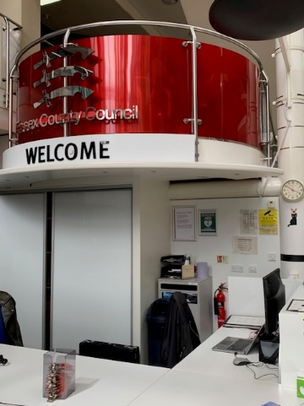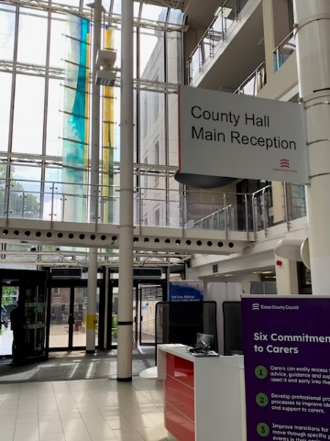

View of Reception from rear entrance (station side)

View of Reception from main front entrance

[Alternative site address if applicable]

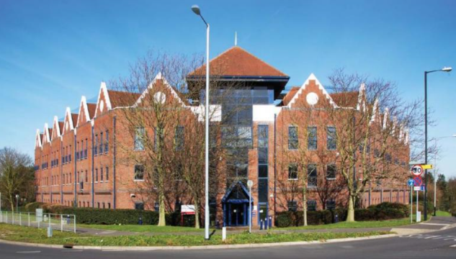

[Details of how to access the building if appropriate]

The approach from the station will take you past the rear of the building/car park where there is no public access. The reception area is located at the front of the building.

What do we do?

[Your team’s mission and purpose]

E.g. Targeted Employment are passionate for SEND jobseekers to be supported on their journey into employment, making sure that their ambitions are heard to ensure they have a bright future.

Our purpose is to…

* Enable young people to own, voice and champion their employment goals
* Instil confidence in families/carers to ensure employment is an option for all
* Bridge the gap between education and employment by increasing pathways and community inclusion
* Embed vocational profiling as a tool to determine motivation, confidence and resilience whilst identifying skills and talents needed for work
* Develop an Essex standard to create meaningful paid jobs through generating inclusive employers

Where do we sit within Essex County Council?

Targeted Employment

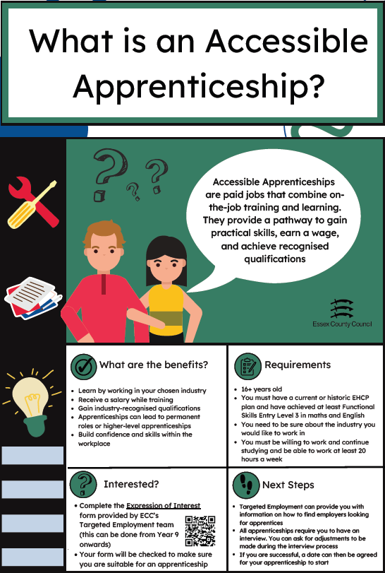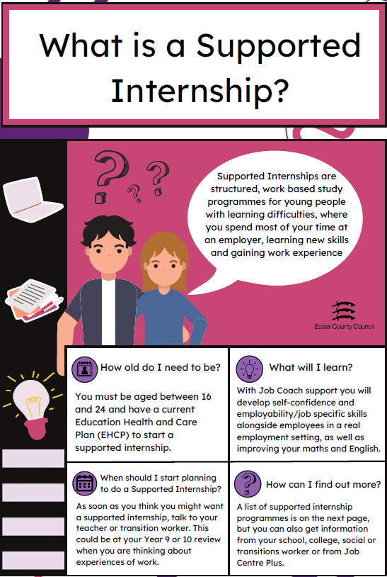 We create Pathways to Employment & help employers become more inclusive

[useful websites or weblinks] e.g.

[Pathways to Employment Guide](https://eur02.safelinks.protection.outlook.com/?url=https%3A%2F%2Fessexcc.pagetiger.com%2Femploymentpathways&data=05%7C01%7C%7C5ba29dc55016419e4c9e08da6af6c8c1%7Ca8b4324f155c4215a0f17ed8cc9a992f%7C0%7C0%7C637939905402962173%7CUnknown%7CTWFpbGZsb3d8eyJWIjoiMC4wLjAwMDAiLCJQIjoiV2luMzIiLCJBTiI6Ik1haWwiLCJXVCI6Mn0%3D%7C3000%7C%7C%7C&sdata=y%2FvSyN6srk3aidmSKRppI2tcSBZp9STdhLvfwjcaJRk%3D&reserved=0)

[Employer Guide](https://eur02.safelinks.protection.outlook.com/?url=https%3A%2F%2Fessexcc.pagetiger.com%2Femployerguide&data=05%7C01%7C%7C5ba29dc55016419e4c9e08da6af6c8c1%7Ca8b4324f155c4215a0f17ed8cc9a992f%7C0%7C0%7C637939905402962173%7CUnknown%7CTWFpbGZsb3d8eyJWIjoiMC4wLjAwMDAiLCJQIjoiV2luMzIiLCJBTiI6Ik1haWwiLCJXVCI6Mn0%3D%7C3000%7C%7C%7C&sdata=YQfKUxUClVAw9%2BgeBj5infi8DwybcITqkmysquj2Phc%3D&reserved=0)

Definitions you may find useful…

[applicable to your business]

**Access to Work** - the Department for Work and Pensions can help to pay for practical support for individuals who have a disability, health, or mental health condition so they can start work, stay in work or start their own business. It can pay for things like special equipment, fares to work, a support worker or job coach in the workplace or a communicator at a job interview

**EHCP (Education Health and Care Plan)** – a legal document outlining a young person’s special educational, health, and social care needs

**HNF (High Needs Funding)** – this is money that schools/colleges can apply for to help them to provide extra support a young person with a high level of special education needs

**IAG (Information, Advice and Guidance)** - range of services to help young people make appropriate career decisions and choices, which are informed and well thought through

**Job Coach** - someone who is employed to help people with disabilities prepare for a job, or learn and perform their work duties

**Local Authority** – administrative offices that provide services within a local area. Essex County Council (ECC) is a Local Authority

**Local Offer** – this is published by ECC and advises what support is available for children and young people with special educational needs and/or disabilities, and their families. It includes information about education, health and care, training, employment, and independent living services <https://www.essexlocaloffer.org.uk/>

**NEET (Not in Education, Employment, or Training)** – this refers to a young person who is unemployed and not receiving an education or vocational training

**PfA (Preparing for Adulthood)** – this term is used to describe the time in life when you move from being a child to an adult and the planning and support that may be needed around education and employment, independent living, health and wellbeing, money and making your own decisions

**Quadrants** – these are the geographical areas that Essex County Council divide the county into to be able to provide services to all its residents. Essex is divided into Mid (Braintree, Chelmsford, Halstead and Maldon), North (Colchester and Tendring), South (Basildon, Billericay, Brentwood, Castle Point, Rochford and Wickford) and West (Epping, Harlow and Uttlesford)

**Reasonable Adjustments** – changes that organisations are required to make to remove or reduce the effect of an individual’s disability so they can apply for or do a job. Changes could be made to the physical environment (perhaps installing a ramp), the ways things are done (such as a change in working hours) or by getting someone to help the individual within their role

**SEMH (Social, Emotional & Mental Health) Team** – specially trained practitioners that help children and young people in education with their emotional wellbeing and mental health

**SEND (Special educational needs and disability)** – a young person has special educational needs and disabilities if they have a learning difficulty and/or a disability

**SEND Careers Team**– they support young people aged 14 to 25 with an Education, Health and Care plan, with preparing for adult life. They will explore what a young person likes at school/college*,* their interests, skills and ideas for when they leave education

**Social worker** –theywork with individuals and families to help improve outcomes in their lives. This may be helping to protect vulnerable people from harm or abuse or supporting people to live independently

**Supported Employment** –this is used to help people with learning disabilities, autism and/or disabilities to secure and stay in paid employment. Staff work with jobseekers to develop their confidence and skills and then match and support them to suitable roles within their local community

**Vocational Profile** – a document that is produced through talking to a young person to help them make their own choices about work and to find out what support they may need to reach their employment goals

Meet the team

Suzanne

What people like and admire about me…

* I have a can-do attitude, I think of solutions, not barriers
* I can always think outside the box!
* Depth of knowledge
* People value me as a colleague
* Quirky sense of humour
* Thoughtful & reflective



What’s important to me…

To be well informed, I thrive on knowing the bigger picture, where I can fit in and how I can contribute & make a difference.

I love seeing the results of my teamwork and how together we have made things happen!

I like to keep my knowledge up to date and enjoy reading legislation, practice, and policy. I love figuring out how pieces of information fit together like jigsaw pieces to bring clarity to something.

To have new things to learn, I like a good challenge and to have some of my work role involving figures and accounts.

Being part of a team in which all members and ideas are valued

I really respect honesty and openness as I hate the feeling that I have let people down. I would rather be told directly if my work hasn’t been suitable, or I’ve said something to upset you.

To have a flexible start & finishing times so I can manage my home life with work without getting stressed.

I am part of a large busy family, keeping in contact with them is extremely important to me.

How best to support me…

* I can often think very quickly, especially when I am making links between different things. This means that I will talk quickly, and I need to be reminded to slow down.
* I like to share my ideas as I’m creating them and having someone to listen and offer feedback when I am developing my thoughts really helps.
* If you’re trying to get in touch don’t just rely on email – I’m not being rude if I don’t reply instantly, I’ll just be working my way through an overloaded day.
* I work well under pressure, trust me to deliver.

What people like and admire about me…

* Approachable and supportive
* Driving forward innovative ways of working for the needs of young adults
* Will always go the “extra mile” for the best outcome
* My assertiveness and the ability to challenge situations as they arise
* The ability to sustain quality contacts and networks
* The fact I am loyal to ECC

Jon



What’s important to me

Promotion of Careers and supporting the development of Essex provision to high standards

The ability to contribute to discussions and feel my input is valued

Feeling valued and respected as part of the wider SEND team

Daddy – day care time is important to me so flexibility in the role is very important to me and my support network

Finding solutions to overcome organizational defensiveness, breaking down barriers to develop positive change.

To keep on top of my tasks and responsibilities and to have a structured approach.

To not lose my careers skillset

How best to support me…?

* Provide clear instruction as to a task and enable me to follow through instructions
* I appreciate honesty and constructive feedback
* I respect open discussion if there are any concerns within the team
* Getting to know me and my strengths as a resource tool
* Give me the opportunity to shine – Don’t reign me in
* Trust that if I need help, I will ask
* I like to see how a piece of work fits into the “bigger picture”
* Having quiet time to learn and reflect

What people like and admire about me…

* I have a real passion for helping people identify what is important to them.
* Giving someone a voice when they feel they are not being heard
* Solution focused thinking
* Funny sense of humour (it’s a family trait)
* Always looking at what we can do…. Not what we can’t do
* Breaking down stigma
* Valued for my knowledge and skills
* Will always make time for people in need

Tina

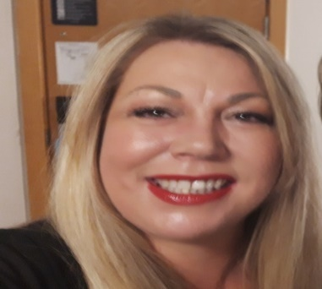

How best to support me…?

* I am a visual learner and am not afraid to ask to be taught like a 5-year-old. I like to watch and learn from others, I like to pick peoples brains and have discussions on topics that are new to me
* When I am learning I like to be in a quiet place, I struggle when there is too much distraction
* I like to get opinions on my work and ask for positive feedback
* I like to finish tasks on time, but I will take longer if I am not happy with it, I like to get things done to a good standard
* I am not afraid to be the first one up, I am happy to role play, I like to work in a team
* I would prefer someone to tell me if they are busy than ignore me. I would rather wait for quality time than be rushed with a two-minute conversation
* I may need to get up in a long meeting to move around due to my back problem

What’s important to me

Firstly, family and friends, knowing that they are happy and succeeding in life.

Proud of my boys for becoming the men they are. Having flexible working time so I can look after my grandchildren.

Feeling valued by my peers and management team, I will always give my support, commitment and loyalty to my organisation and expect the same in return.

Straight talking people, I would rather be told the truth, even if I may not like it.

I think it’s important that people understand that a small problem to one person can be a big problem to someone else.

I like to keep up to date on legislation and policy that is connected to my work.

Self-learning and pushing myself to be the best I can, life and lived experiences can be just as important as academic learning.

Mental health and wellbeing, making time for myself, having a good work & home life balance.

Holidays… holidays… Oh and weekends away. We are more efficient and healthier workers when we balance our lives.

Emma

What people like and admire about me…

* I always have a friendly and helpful disposition
* Passionate about meeting the needs of young people
* I would never ask someone to do a job that I wasn’t willing to do myself
* Good sense of humour
* I’m able to grasp new concepts quickly
* I’m extremely patient
* Effective communication skills



What’s important to me

Learning new skills and being able to implement these within my own practice.

Being organised. I like to know where I am and what I’m doing at all times…I love a list!

Sharing ideas and being part of a closely-knit team – a problem shared is a problem halved.

Working in a harmonious environment. I don’t like conflict or negativity within the workplace.

I’m a perfectionist and a stickler for detail. This does mean that I can get carried away and caught up in the finer details!

My family are everything to me, so I really appreciate the flexibility of working for an organisation with a positive work/life balance ethos.

I love to travel and experience different cultures, and definitely feel happier and more energised when the sun is shining!

How best to support me…

* Give me feedback on how I am doing as I can worry unnecessarily about my own performance. I will appear confident but sometimes feel quite anxious.
* I always give 100% to whatever I’m doing so please don’t ask me to cut corners.

* I respond well to deadlines and can work under pressure; I can be relied on to get a job done.
* Drafting or outlining a task before putting my ideas forward to others is often helpful to me.
* Making notes or taking minutes helps me order my thoughts and retain important information.

Jethro

What people like and admire about me…

* Calm and can cope with a pressured workload
* Passionate about employment and achieving excellent outcomes for all
* Kind and generous
* Good sense of humour
* Can see the big picture and plan strategically
* Gets on with everyone



What’s important to me

Supporting people to make significant changes to their lives and to achieve good outcomes.

Seeing positive change within the organisation I am working.

Working with people that understand that my mood can be variable. Sometimes I can seem to be rushing and other days I may seem quiet.

Space to be creative and generate novel and useful ideas.

I like to be a catalyst for change and put forward innovative ideas.

Positive feedback when appropriate to keep me motivated.

Being outside and taking part in exercise, especially on the water, is important to me and helps to keep me balanced.

.

How best to support me…

* Be as positive as possible when providing me with feedback on how I am doing as I struggle with criticism that isn’t constructive
* Please ask me to slow down if I am rushing ahead, I have two speeds fast and slow and often struggle to find the middle ground

* I may not always ask for help so feel free to chip in if I look like I am struggling because I probably am
* I like to be involved in higher level discussions and given the opportunity to work beyond my role when appropriate
* Reading is not my strength so please allow me quiet time when reading is involved

Terry

What people like and admire about me…

* Innovative, solution focussed, problem solver
* Relentlessly positive in my approach to work and life
* Enjoy motivating and coaching others
* Supportive and friendly
* Not afraid of trying new things



What’s important to me

I am passionate about SEND and am relentless in my pursuit for fairness and equity

I am extremely family orientated; I love spending time with my family

I am an innovator and like to be able to explore and share ideas

I enjoy structure and clear goals

I feel uncomfortable not working to a high standard

I am a Mental Health advocate and appreciate the importance of life balance

I love learning new things and my list of fads is endless - piano, guitar, gym, rowing, fasting, Wim Hof, Darts, meditation, snooker, karate. I never let someone’s negative opinion stop me from doing something

How best to support me…?

* I like to receive information quickly and concisely. My concentration will drift if people don’t get to the point
* I am self-motivated and hardworking, but I really appreciate feedback on my performance
* I am self-reflective and quite critical of my own performance. I will appear confident but sometimes feel quite anxious
* I am goal orientated and happy to work under pressure or to a timescale
* I struggle with negativity, and this can impact my own motivation

Crystal

What people like and admire about me…

* My integrity and passion.
* I’m thorough, hardworking and can build a knowledge base quickly
* I care and I listen
* I advocate for people and aim to enable and find solutions
* I’m resourceful. I like to find ways to streamline, save workload and make a task serve the purpose/multiple purposes.
* I’m reliable as I’ll always find a way.



What’s important to me

Being adaptable to the team for our young people- I’m person centred and believe everyone has value and strength

I was diagnosed autistic in adulthood. I have amazing hyperfocus ability and the ability to retain a real depth of knowledge.

It’s important to me to balance and prioritise the right things. Fresh air and walking help me to process and re-centre. It makes me more productive and efficient. It brings me back to the bigger picture and helps me to strategize.

My family are everything and we are big West Ham fans.

I have a creative streak and I’m resourceful. Crafting ‘lights me up’ and I love making cakes.

I tend to deflect conversations about me personally. I love hearing different perspectives that challenge my thinking about life and priorities.

I’m a positive and upbeat person and I thrive in positive and calm energy. Energy feels tangible to me, and I reflect and reframe internally. I’m smiley and I like my own company.

How best to support me…

I can tune out when focussed on getting something done. Saying my name helps me to cue in

I can internalise when processing. Being direct and constructive helps me to process quicker. I tend to self-coach, and I like coaching approaches. I am a deep thinker

I like to know what my day will look like in advance but can and do flex. I benefit from a little notice to mentally task switch and prepare

Hybrid working helps me to balance socially based and desk top working. I can self-manage and self-reflect

Tell me about your projects and objectives. I like to know how to support the bigger picture and enjoy seeing others succeed!

Paige

What people like and admire about me…

* Approachable and supportive
* I always have a willing and can-do attitude.
* Always trying my best whenever I can
* Will always go the “extra mile” for the best outcome
* I may not be talkative but if I have an opinion, I will voice it

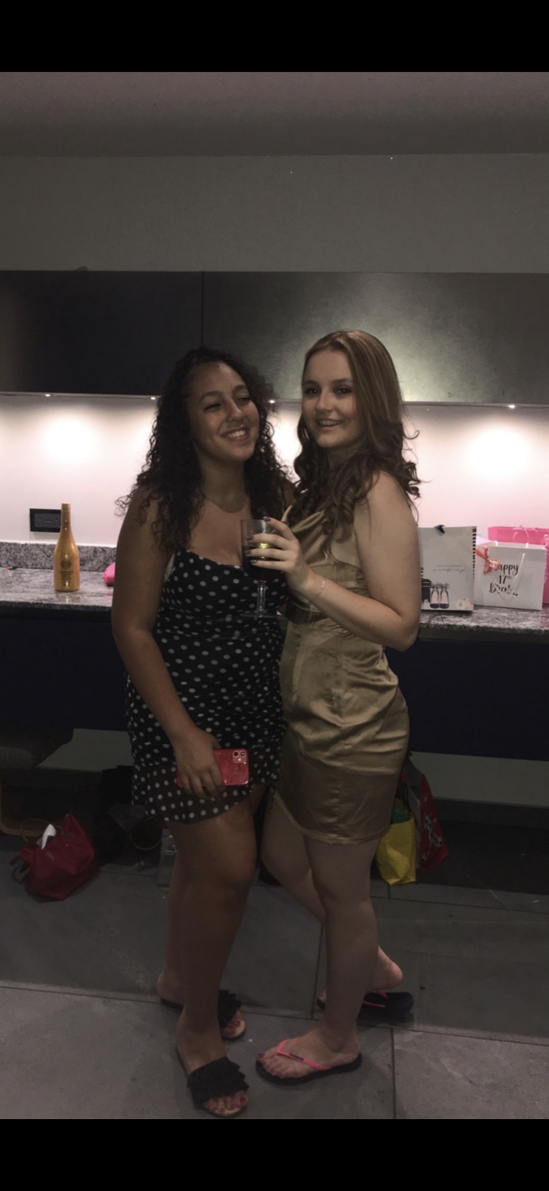

What’s important to me

* Being able to spend time with my friends and family
* The ability to work without constant monitoring to allow me to show my true talent
* Feeling valued and respected as part of a team
* Fitness and my work/life balance
* Experiencing new adventures and exploring different parts of the world.
* Being able to improve my skills and talents through training or experiences
* Making time for people in need
* Going for runs and working out at the gym

How best to support me…?

* Let me do a task while learning and I will pick it up fast
* I appreciate honesty and constructive feedback
* Trust that if I need help, I will ask
* Allow me space to show what I can achieve by myself
* Allow me the ability to always try to improve my talents

[Template]

What people like and admire about me…

What’s important to me

How best to support me…?

Your Timetable

|  |  |  |  |  |  |
| --- | --- | --- | --- | --- | --- |
|  | **Monday** | **Tuesday** | **Wednesday** | **Thursday** | **Friday** |
| 9.00am |  | Meet [contact] at [your business] Reception, [town]  Check in, wellbeing and plan for the day | Meet [contact] at [your alternative business location], [town]  Orientation of building, including toilets/where to have lunch/First Aid/Fire Evacuation procedures  Check in and plan for the day | Check in with [contact] online via Teams  (all Teams invitations to be emailed in advance)  Plan for the day | Check in with [contact] online via Teams  Plan for the day |
| 10.00am | Meet [contact] at [your business] Reception, [town]  Right to work documentation  Orientation of building including toilets/where to have lunch/First Aid/Fire Evacuation procedures  Talk about plan for the week | Employment & Wellbeing event (location)  Orientation of event area  Checking understanding of task to be undertaken | Functions within [your organisation]  Mini Project outline: E.g.: How can different roles or organisations help young people with disabilities enter employment?  Learning checkpoint: Questions to ask professionals that relate to the project | Independent research/Mini Project | Online Teams meeting with [contact]  Questions/  proof reading/Dry run of presentation |
| 10:45am | **Break** | **Break** | **Break** | **Break** | **Break** |
| 11.00am | Informal meet the team. What does [your business/team] do?  Introduction to first task (e.g. One Page Profile) | Employment & Wellbeing event (location)  Check in and informal discussion of findings so far | Meeting with [professional from another team]  Research: Jobs that support with disabilities and mental health challenges | Online Teams meeting with [professional from another team]  Continuation of research/Mini Project | Finalise mini project |
| Midday | **Lunch** | **Lunch** | **Lunch** | **Lunch** | **Lunch** |
| 1.00pm | Meeting with [team member]: [chat about their role]  Completion of One Page Profile | Employment & Wellbeing event (location) | Meeting with [professional from another team]  Continue research | Afternoon check in with [contact]  Continuation of Mini project | Afternoon check in with [contact]  Presentation of project to team |
| 2.00pm | Introduction to tomorrow’s activities (e.g. Employment event)  Learning checkpoint: Planning of research activity to be undertaken at event | Debrief with team following the event  Learning checkpoint: research findings | Learning checkpoint:  Supporting roles within [your organisation/external partners] – link to mini project outcomes | Online Teams Learning checkpoint/  Student feedback discussion | Feedback, Team & Student wrap-up |
| **3.00pm** | **Finish** | **Finish** | **Finish** | **Finish** | **Finish** |

Your Timetable

|  |  |  |  |  |  |
| --- | --- | --- | --- | --- | --- |
|  | **Monday** | **Tuesday** | **Wednesday** | **Thursday** | **Friday** |
| 9.00am |  |  |  |  |  |
| 10.00am |  |  |  |  |  |
| 10:45am | **Break** | **Break** | **Break** | **Break** | **Break** |
| 11.00am |  |  |  |  |  |
| Midday | **Lunch** | **Lunch** | **Lunch** | **Lunch** | **Lunch** |
| 1.00pm |  |  |  |  |  |
| 2.00pm |  |  |  |  |  |
| **3.00pm** | **Finish** | **Finish** | **Finish** | **Finish** | **Finish** |

Your activities this week

Create your own One Page Profile

We put a lot of emphasis on person-centred planning, which means the more we know about an individual, the more we can help and support them to make their own choices about the future.

The team have all created a One Page Profile (included in this pack). We would like you to create and share with us your own profile considering:

* What people like and admire about you
* What (or who) is important to you
* How to best support you

A template will be provided for you, but you are more than welcome to create your own layout if you would prefer.

Optional: Create a Naturally Talented Me “See Me” digital profile

Naturally Talented Me (<https://naturallytalentedme.co.uk/>) is an online profiling platform, designed to help jobseekers identify and promote their natural talents to employers.

We would like you to create a free online profile (a bit like an interactive CV) that will help you identify your natural talents and how they link to employment attributes. These can then be presented to employers in an engaging and dynamic way that shows what you’re really made of.

This is a free platform to use, and you can also add photos and videos at a later date if you wish to show employers what you are able to achieve. To create an account, use this link:

<https://www.naturallytalentedme.com/login.aspx>

Your activities this week

These activities will be completed during your time spent with the Targeted Employment team. Support will be available to you throughout your time with us.

Mini Project: How can different roles or organisations help young people with disabilities enter employment?

We would like you create a short presentation exploring the different roles that you have learned about this week and how these could help support a young person to consider employment when they leave education.

As part of your initial research, we would like you to:

* Mind map the different types of disabilities that you can think of (these could be learning, physical, sensory, or mental health difficulties)
* Consider how these could affect an individual trying to find or sustain work and simple adjustments that could be made to cater for their needs within employment settings
* List the different roles or organisations that you have met this week and what their main functions are
* Choose at least two different roles/organisations and explain how these can help young people with disabilities health challenges to consider employment when they leave education

As part of this project, you will also be asked to think about how inclusive your own school is when considering employment/next steps, and if there is anything that could be done to make it more inclusive?

Whichever presentation method you choose, we would like you to present your findings to the team at the end of the week - we will then provide feedback as part your work experience evaluation.

[Some useful websites]:

[National Careers Service - explore careers](https://nationalcareers.service.gov.uk/explore-careers?gclid=Cj0KCQjw8NilBhDOARIsAHzpbLD0xzobdUQXmyeCLt_Wlx1frJ6eLLoQJYFRZ0db9k6GunnTsqdIXSgaAo2mEALw_wcB)

[National Careers Service - mental health roles](https://nationalcareers.service.gov.uk/search-results?SearchTerm=Mental+Health)

[National Careers Service - working with disabilities](https://nationalcareers.service.gov.uk/search-results?SearchTerm=disability)

[NHS - working in mental health](https://www.england.nhs.uk/mental-health/working-in-mental-health/)

[SCOPE - Reasonable Adjustments](https://www.scope.org.uk/advice-and-support/reasonable-adjustments-at-work)